
TWO-DAY TRAINING ON
ALERT 360-DEGREE FEEDBACK

Introduction

360 degree feedback offers a unique opportunity for managers to find out how their boss(es), colleagues, direct reports, fellow team members, internal and external customers and suppliers perceive their behaviour. It boosts self-confidence, helps managers put more balance into their lives and teaches them to become more effective at work and at home. Key findings reveal that feedback is an important element of a person’s professional and personal development. Experience shows that the most effective executives are learners who turn everything into a learning experience.

What you will learn :
- Getting a clear picture of how to use the Alert 360° evaluation tool in a developmental setting
- Obtaining insight in how to apply the principles of 360° feedback

Programme

Day 1

Outline of the 360° instrument, and the research upon which it is based
Preparing the interpretation of the report
Validity and reliability
Feedback workshop
Example of Alert360° feedback
Development planning

Day 2

Practical exercise in giving feedback
Observation of interaction in feedback
Applications
Possibilities and limitations of the instrument
Analysis of the introductory process
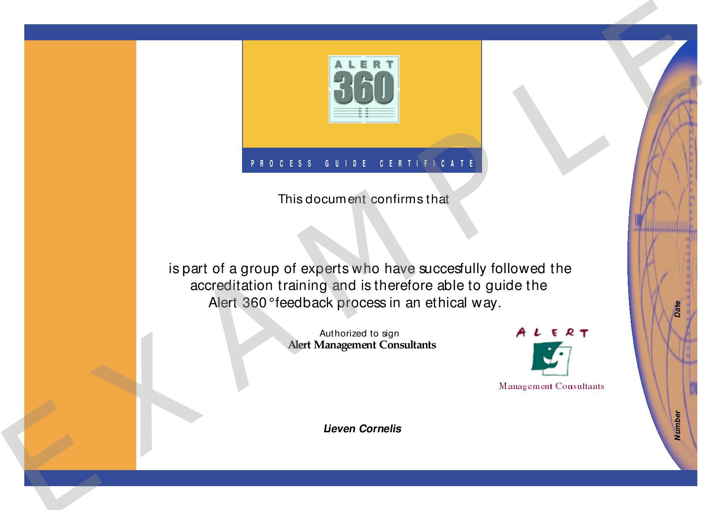
Setting up coaching programmes
After comleting succesfully this program, you will receive your personal prove of certification.

